**Assignment – SQL Queries**

Name : Prithviraj Wable

Email ID : [prithviraj.wable@awign.com](mailto:prithviraj.wable@awign.com)

Contact No. : 8608156583

Q)

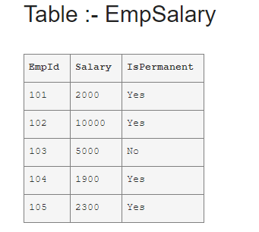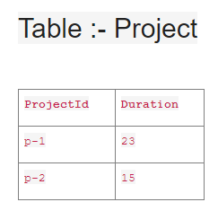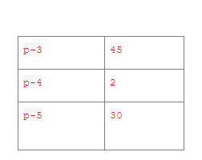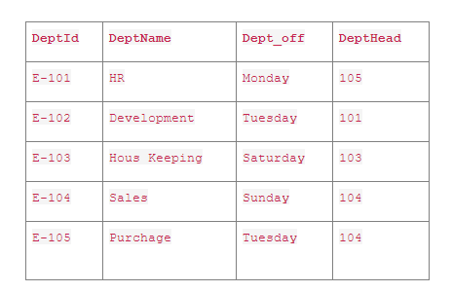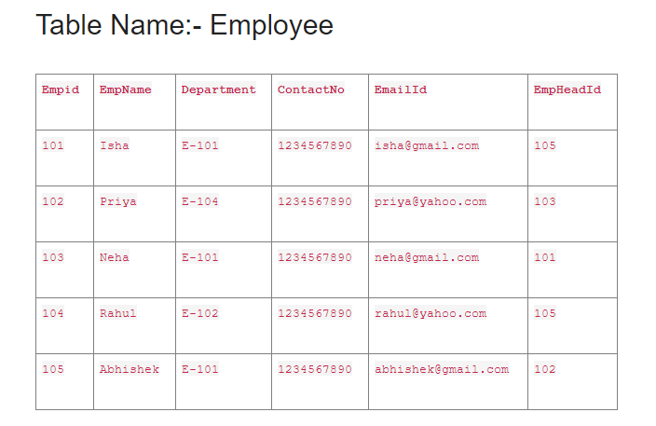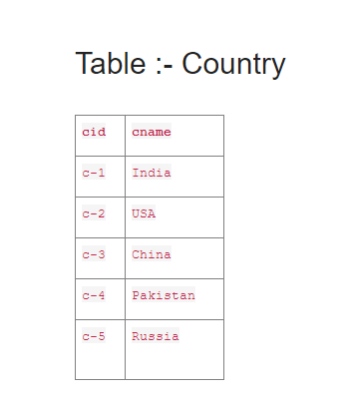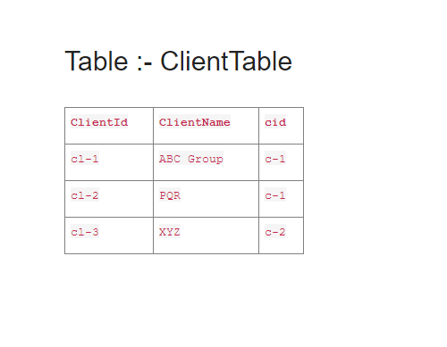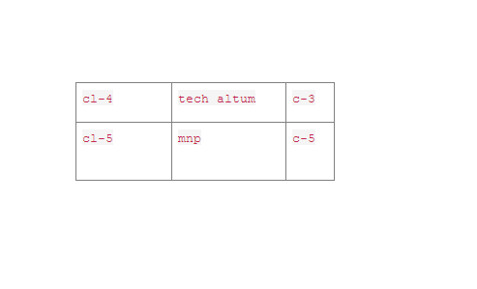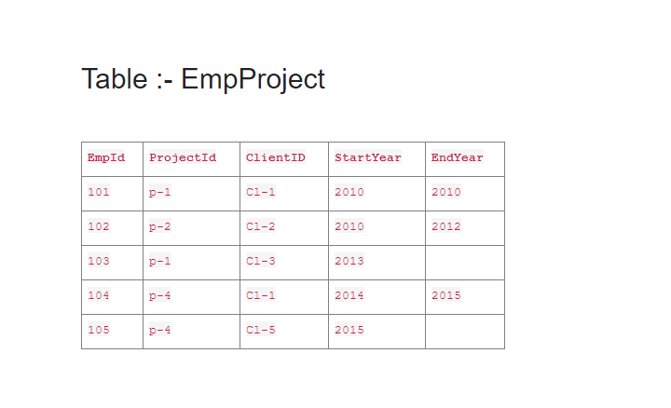

Solution :

1.   Select the detail of the employee whose name starts with P.

* **select * from employee where empname like 'p%'**

Output:

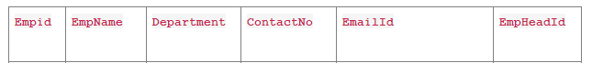

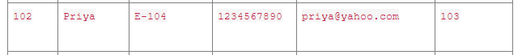

2.   How many permanent candidates take a salary more than 5000?

* **select count(salary) as count from empsalary where ispermanent='yes' and salary>5000**

Output:

|  |  |
| --- | --- |
|  | Count |
| 1 | 1 |

3.   Select the detail of the employee whose emailId is in gmail.

* **select * from employee where emailid like '%@gmail.com'**

Output:

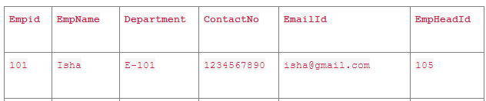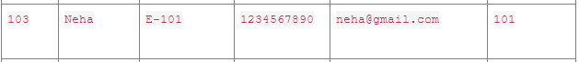

4.   Select the details of the employee who works either for department E-104 or E-102.

* **select * from employee where department in ('E-102','E-104')**

Output:



  
 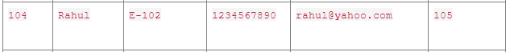

5.   What is the department name for DeptID E-102?

* **select deptname from empdept where deptid ='E-102'**

Output:

|  |  |
| --- | --- |
|  | deptname |
| 1 | Development |

6.  What is the total salary that is paid to permanent employees?

* **select sum(salary) as salary from empsalary where ispermanent='yes'**

Output:

|  |  |
| --- | --- |
|  | salary |
| 1 | 16200 |

7.  List name of all employees whose name ends with a.

* **select * from employee where empname like '%a'**

Output:

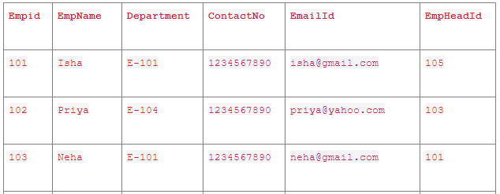

8.  List the number of departments of employees in each project.

* **select count(empid) as employee, projectid from empproject group by projectid**

Output:

|  |  |  |
| --- | --- | --- |
|  | employees | projectid |
| 1 | 2 | p-1 |
| 2 | 1 | p-2 |
| 3 | 2 | p-4 |

9.  How many projects started in 2010.

* **select count(projectid) as project from empproject where startyear=2010**

Output:

|  |  |
| --- | --- |
|  | project |
| 1 | 2 |

10.  How many projects started and finished in the same year.

* **select count(projectid) as project from empproject where startyear=endyear**

Output:

|  |  |
| --- | --- |
|  | project |
| 1 | 1 |

11.  select the name of the employee whose name's 3rd character is 'h'.

* **select * from employee where empname like '__h%'**

Output:





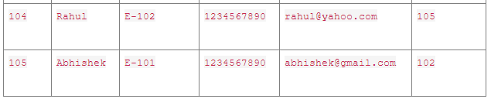

1.   Select the department name of the company which is assigned to the employee whose employee id is greater 103.

* **select deptname from empdept where deptid in (select department from employee where empid>103)**

Output:

|  |  |
| --- | --- |
|  | deptname |
| 1 | HR |
| 2 | Development |

2.   Select the name of the employee who is working under Abhishek.

* **select empname from employee where empheadid =(select empid from employee where empname='abhishek')**

Output:

|  |  |
| --- | --- |
|  | empname |
| 1 | Isha |
| 2 | Rahul |

3.   Select the name of the employee who is department head of HR.

* **select empname from employee where empid =(select depthead from empdept where deptname='hr')**

Output:

|  |  |
| --- | --- |
|  | empname |
| 1 | Abhishek |

4.   Select the name of the employee head who is permanent.

* **select empname from employee where empid in(select empheadid from employee) and empid in(select empid from empsalary where ispermanent='yes')**

Output:

|  |  |
| --- | --- |
|  | empname |
| 1 | Isha |
| 2 | Priya |
| 3 | Abhishek |

5.   Select the name and email of the Dept Head who is not Permanent.

* **select empname, emaildid from employee where empid in(select depthead from empdept ) and empid in(select empid from empsalary where ispermanent='no')**

Output:

|  |  |  |
| --- | --- | --- |
|  | empname | emailid |
| 1 | Neha | neha@gmail.com |

6.   Select the employee whose department off is Monday

* **select * from employee where department in(select deptid from empdept where dept_off='monday')**

Output:

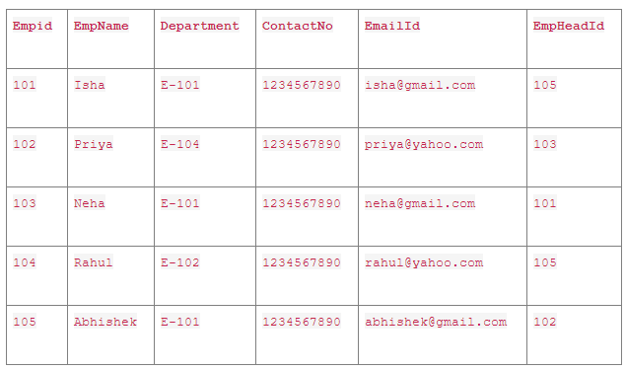





7.   Select the Indian clients details.

* **select * from clienttable where cid in(select cid from country where cname='india')**

Output:

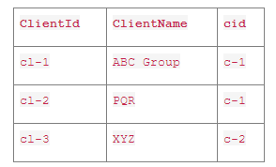

8.   Select the details of all employees working in the development department.

* **select * from employee where department in(select deptid from empdept where deptname='development')**

Output:

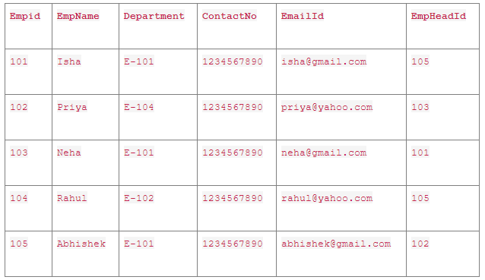



---------------------------------------------------------------END-----------------------------------------------------------------